[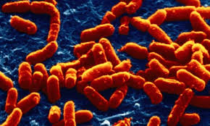](http://www.google.com/imgres?imgurl=http://static.guim.co.uk/sys-images/Guardian/Pix/pictures/2009/4/14/1239726486138/Escherichia-coli-bacteria-001.jpg&imgrefurl=http://www.theguardian.com/science/blog/2009/jul/24/bacteria-computer&h=276&w=460&tbnid=01mBLh9WLEpgaM:&zoom=1&docid=C5kOGLYsC2i5xM&ei=c_RwU_LHC4iryATBvYKYAQ&tbm=isch&ved=0CHUQMygbMBs&iact=rc&uact=3&dur=948&page=2&start=12&ndsp=16) Bacteria Photo #1

[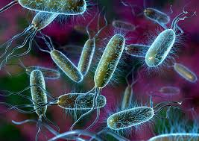](http://www.google.com/imgres?imgurl=http://www.geek.com/wp-content/uploads/2014/02/soap2.jpg&imgrefurl=http://www.geek.com/science/geek-answers-do-anti-bacterial-soaps-really-matter-1585770/&h=636&w=900&tbnid=3-GSH4bW26wRhM:&zoom=1&docid=QysCieJ0bvLMJM&ei=c_RwU_LHC4iryATBvYKYAQ&tbm=isch&ved=0CIkBEDMoLzAv&iact=rc&uact=3&dur=276&page=4&start=45&ndsp=16) Bacteria Photo #2

[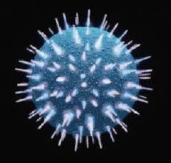](http://www.google.com/imgres?imgurl=http://www.armageddononline.org/image/virus1.JPG&imgrefurl=http://www.armageddononline.org/viruses.html&h=305&w=320&tbnid=03znmNuq9bUb-M:&zoom=1&docid=kxFhq1PUvaodxM&ei=vPNwU__yKY-UyATkrYDoBQ&tbm=isch&ved=0CGEQMygNMA0&iact=rc&uact=3&dur=549&page=1&start=0&ndsp=14) Virus #1

[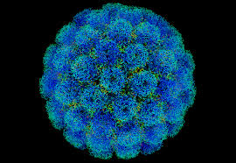](http://www.google.com/imgres?imgurl=http://upload.wikimedia.org/wikipedia/commons/6/6a/Symian_virus.png&imgrefurl=http://en.wikipedia.org/wiki/SV40&h=687&w=996&tbnid=t2TcmzBuCaZTNM:&zoom=1&docid=bTrjtaD75lXJIM&ei=7vNwU-eDMMGYyASgnoKIDA&tbm=isch&ved=0CFwQMygIMAg&iact=rc&uact=3&dur=482&page=1&start=0&ndsp=14) Virus #2