Chapter 10: The Nature of Force
Guided Note Packet #2
Name: _________________________________
Hour
Newton’s Law’s of Motion
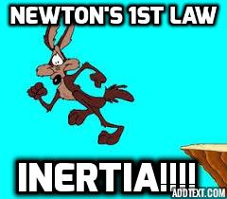
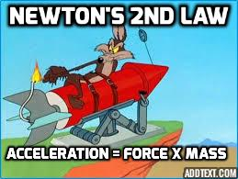
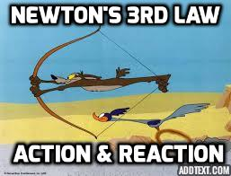
The First Law of Motion (Chapter 10, Section 3)

1. For an unmoving object to start moving, a(n) ________________________ has to act on it.

2. What is Newton’s first law of motion?
________________________________________________________________________
________________________________________________________________________
________________________________________________________________________
________________________________________________________________________

3. What is inertia?
________________________________________________________________________
________________________________________________________________________

4. What is another name for Newton’s first law?
________________________________________________________________________

5. The amount of inertia an object has depends on its
________________________

6. Inferring: Use what you know about inertia to explain why you feel pressed back into the seat of a car when it accelerates
________________________________________________________________________
________________________________________________________________________

In the box below, draw your own example of Newton’s 1st Law of Motion. Think of something you may see in your everyday life.

The Second Law of Motion
6. What is Newton’s second law of motion?
________________________________________________________________________
________________________________________________________________________
________________________________________________________________________

7. What is the equation that describes the relationship among the
quantities of force, mass, and acceleration?

______________ = ______________ x ______________

8. Circle the letters of the two answers below that are different names for
the same unit of measure.

a. m/s2
b. N
c. kg · m/s2
d. 1 kg

9. How can you use Newton’s second law to find force?

________________________________________________________________________

10. What are two ways to increase the acceleration of an object?

1-

2-

Turn & Talk Section:

11. Problem SolvingHow could you keep an object’s acceleration the same if the force acting on the object were doubled?

_________________________

12. Applying Concepts Using what you know about Newton’s second law, explain why a car with a large mass might use more fuel than a car with a smaller mass. Assume both cars drive the same distance.

__________________________________________________________________________________

Calculating Force: Find the force it would take to accelerate an 800-kg car at a rate of 5 m/s².
___________________________

Calculating Force: What is the net force acting on a 0.15-kg hockey puck accelerating at a rate of 12 m/s²?
___________________________
In the box, draw your own example of the Second Law of Motion. Think of an example from your everyday life.

Forces
Chapter 10, Section 4
Newton’s Third Law of Motion

1. What is Newton’s third law of motion?
________________________________________________________________________
________________________________________________________________________
________________________________________________________________________
________________________________________________________________________

2. What is the name given to the force exerted by the first object on a
second object? ________________________

3. What is the name given to the force exerted by the second object back on
the first object? ________________________

4. The action and reaction forces in any situation will always be
________________________ and ________________________.

5. Explain why the equal action and reaction forces do not cancel each
other when one person hits a ball.
________________________________________________________________________
________________________________________________________________________
________________________________________________________________________
________________________________________________________________________
________________________________________________________________________

Momentum
6. The product of an object’s mass and velocity is its
________________________.

7. What is the equation you use to determine the momentum of an object?
________________________________________________________________________

8. What is the unit of measurement for momentum?
________________________________________________________________________

Conservation of Momentum

9. What does the law of conservation of momentum state?
________________________________________________________________________
________________________________________________________________________
________________________________________________________________________

10. Suppose a train car moving down a track at 10 m/s hits another train car
that is not moving. Explain how momentum is conserved after the
collision.
________________________________________________________________________
________________________________________________________________________
________________________________________________________________________
________________________________________________________________________
________________________________________________________________________
Turn & Talk Section:
Calculating Momentum A golf ball travels at 16 m/s, while a baseball moves at 7 m/s. The mass of the golf ball is 0.045 kg and the mass of the baseball is 0.14 kg. Which has greater momentum?
_____________________
Calculating Momentum What is the momentum of a bird with a mass of 0.018 kg flying at 15 m/s?
______________________
Calculating Momentum What is the momentum of a 920-kg car moving at a speed of 25 m/s?
________________________
Calculating Momentum Which has more momentum: a 250-kg dolphin swimming at 4 m/s, or a 350-kg manatee swimming at 2 m/s?
_________________________
Applying Concepts What would happen if you tried to catch a ball when you were standing on roller skates?
_________________________
Predicting What is the momentum of a parked car?
________________ Reason: _________________________________________
Relating Cause And Effect Why is it important for drivers to allow more distance between their cars when they travel at faster speeds?
__________________________________________________________________________
Inferring The total momentum of two marbles before a collision is 0.06 kg·m/s. No outside forces act on the marbles. What is the total momentum of the marbles after the collision?
__________________________
In the box, draw your own example of the Third Law of Motion. Think of an example from your everyday life.

Rockets and Satellites
How Do Rockets Lift Off?

1. Which of Newton’s laws explains the lifting of a rocket into space?

________________________________________

2. When a rocket rises, what causes the action force?

________________________________________

3. When a rocket rises, what causes the reaction force?

________________________________________

4. On the diagram of a rocket lifting off the ground, draw and label arrows that show the action force and the reaction force.

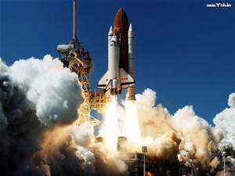

5. When a rocket lifts off the ground, the net force is in an upward
direction. Is the upward pushing force greater or lesser than the
downward pull of gravity? ________________________

What Is a Satellite?
6. Any object that travels around another object in space is
a(n) ________________________.

7. An object traveling in a circle is accelerating because it
is constantly changing ________________________.

8. What is a force called that causes an object to
move in a circle? ________________________

9. For a satellite, what is the centripetal force
that causes it to move in a circle?
________________________

10. Is the following sentence true or false?
Satellites in orbit around Earth continually
fall toward Earth. _____________________

11. Explain why a satellite in orbit around Earth does not fall into Earth.

__________________________________________________________________
__________________________________________________________________

12. A satellite is a projectile that falls ________________________ Earth rather than into Earth.

13. Why doesn’t a satellite need fuel to keep moving?

___________________________________________________________________

14. What force continually changes a satellite’s direction?
________________________

