Images of Surprising Motion Machines………Look at the images below and make predictions on your worksheet about what each machine should do once it is set into motion.
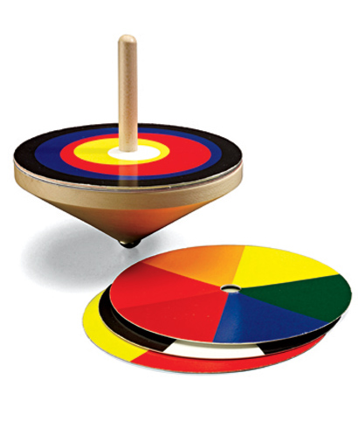Top #1

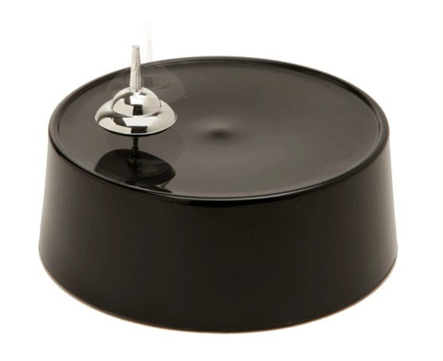
Top #2

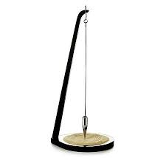Pendulum #1 (Pull back and release)
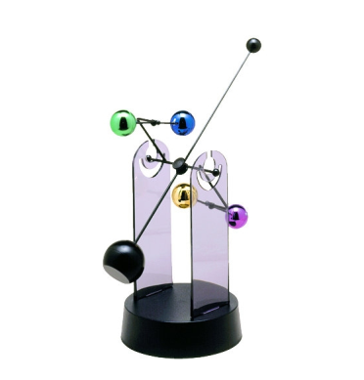Pendulum #2
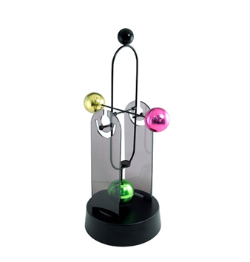Pendulum #3

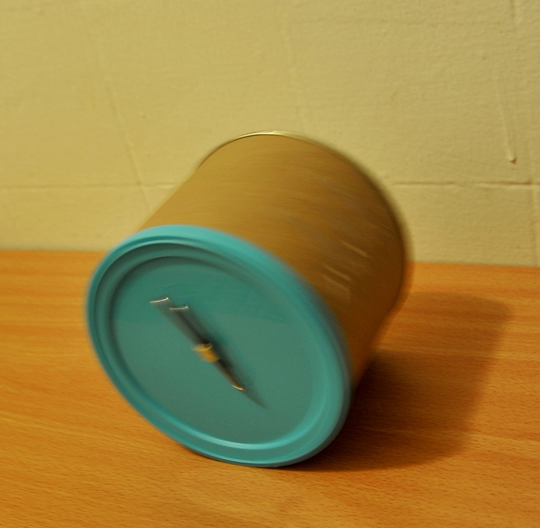
Rolling Can

