What % of Air is really Oxygen?

Air is a mixture of gases - 78% nitrogen and 21% oxygen - with traces of water vapor, carbon dioxide, argon, and various other components.
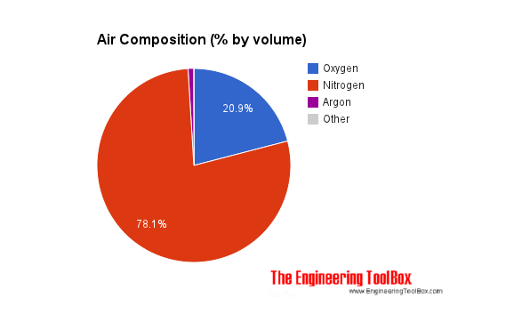
Air is usually modeled as a uniform (no variation or fluctuation) gas with properties averaged from the individual components.
Gas | Ratio compared to Dry Air (%) |  | Molecular Mass  - M -  (kg/kmol) | Chemical Symbol | Boiling Point
 | By volume | By weight |  |  | (K) | (ºC)
Oxygen | 20.95 | 23.20 | 32.00 | O₂ | 90.2 | -182.95
Nitrogen | 78.09 | 75.47 | 28.02 | N₂ | 77.4 | -195.79
Carbon Dioxide | 0.03 | 0.046 | 44.01 | CO₂ | 194.7 | -78.5
Hydrogen | 0.00005 | ~ 0 | 2.02 | H₂ | 20.3 | -252.87
Argon | 0.933 | 1.28 | 39.94 | Ar | 84.2 | -186
Neon | 0.0018 | 0.0012 | 20.18 | Ne | 27.2 | -246
Helium | 0.0005 | 0.00007 | 4.00 | He | 4.2 | -269
Krypton | 0.0001 | 0.0003 | 83.8 | Kr | 119.8 | -153.4
Xenon | 9 10⁻⁶ | 0.00004 | 131.29 | Xe | 165.1 | -108.1

Other components in air
- Sulfur dioxide - SO₂ - 1.0 parts/million (ppm)
- Methane - CH₄ - 2.0 parts/million (ppm)
- Nitrous oxide - N₂O - 0.5 parts/million (ppm)
- Ozone - O₃ - 0 to 0.07 parts/million (ppm)
- Nitrogen dioxide - NO₂ - 0.02 parts/million (ppm)
- Iodine - I₂ - 0.01 parts/million (ppm)
- Carbon monoxide - CO - 0 to trace (ppm)
- Ammonia - NH₃ - 0 to trace (ppm)

